S3: Static website hosting

* Trainer will provide the static website page

<https://github.com/amitopenwriteup/static-website-example.git>

* Download and upload all the website of static website
* In bucket, go to properties section of bucket

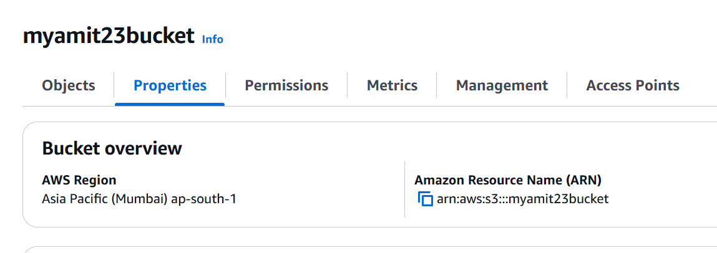

* End of the page you will find, Static website hosting tab

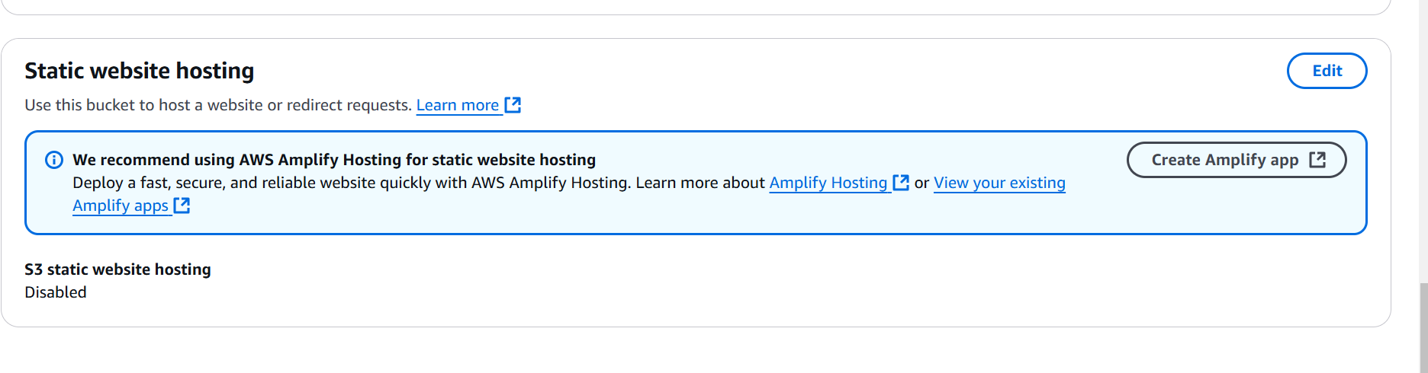

Enable the static website

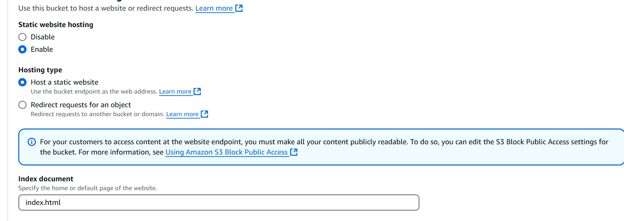

Check the link and you will find the website

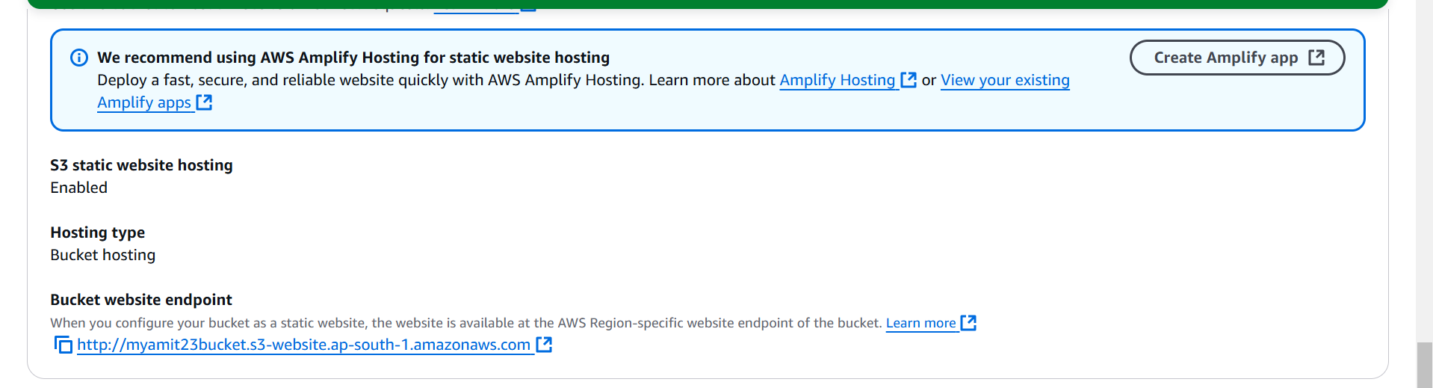

IF you click on bucket website endpoint, it will give the error message

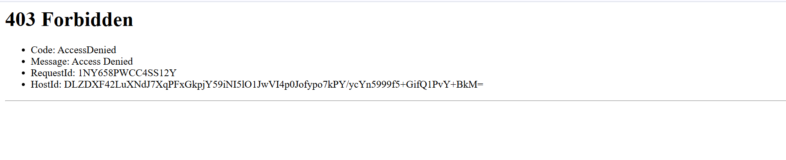

Go to Bucket Permission tab

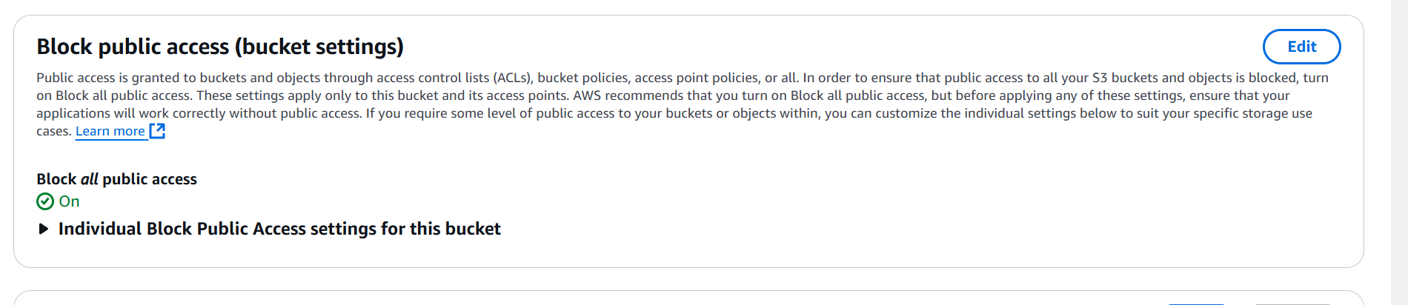

Click on edit and off the public access

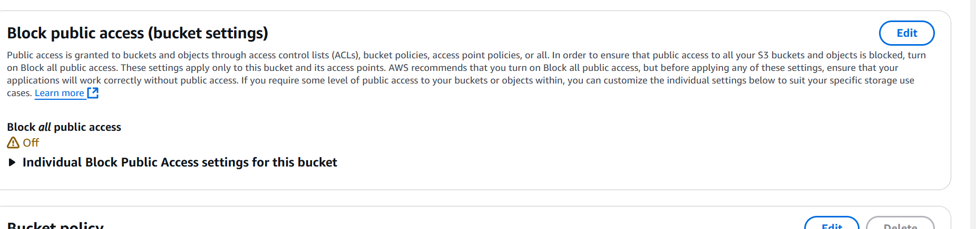

If you check the website endpoint, still it will not accessible since we have not created the policy

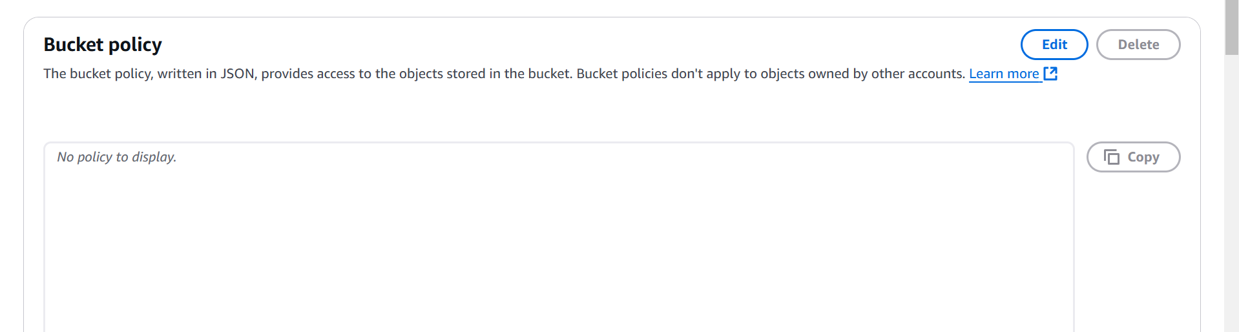

Click on Edit of bucket policy, and click on policy generator

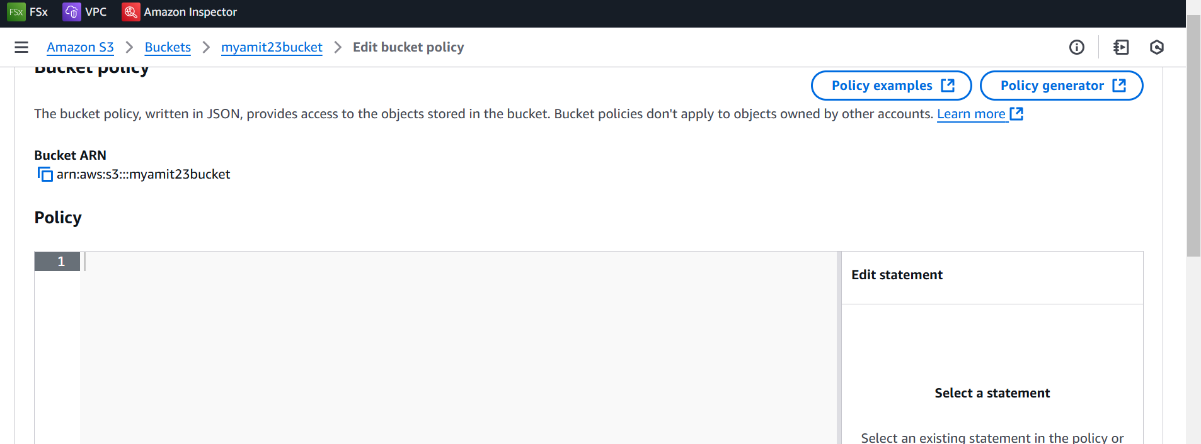

Select the policy type: S3bucket policy

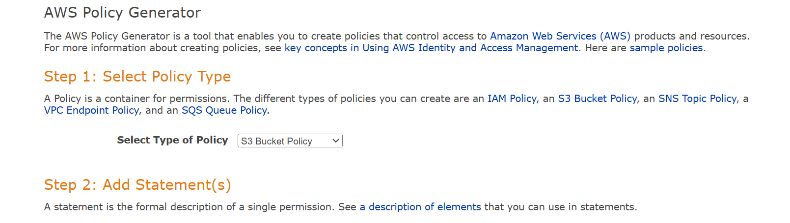

Provide principal: Whom to provide the access

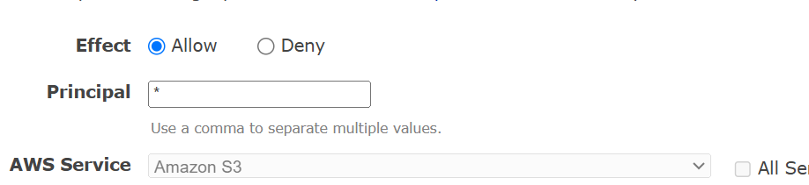

In Action field, select get object

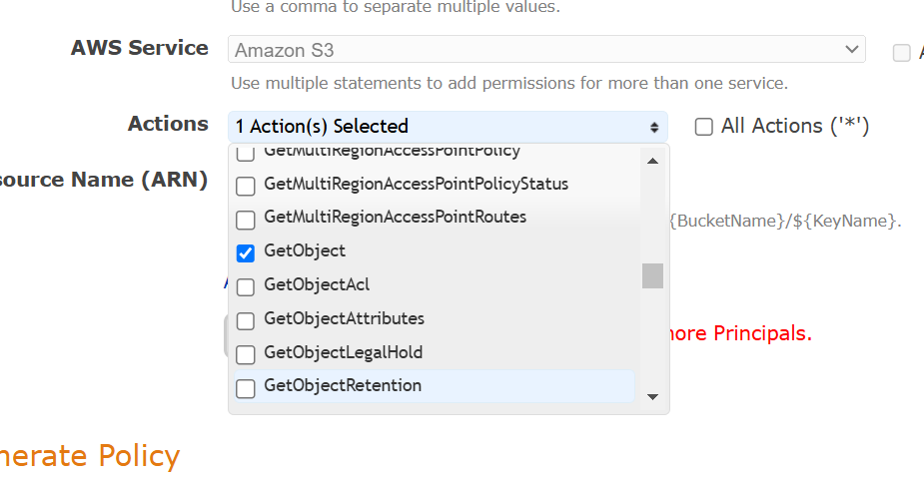

Bucket Arn, you will go to bucket tab

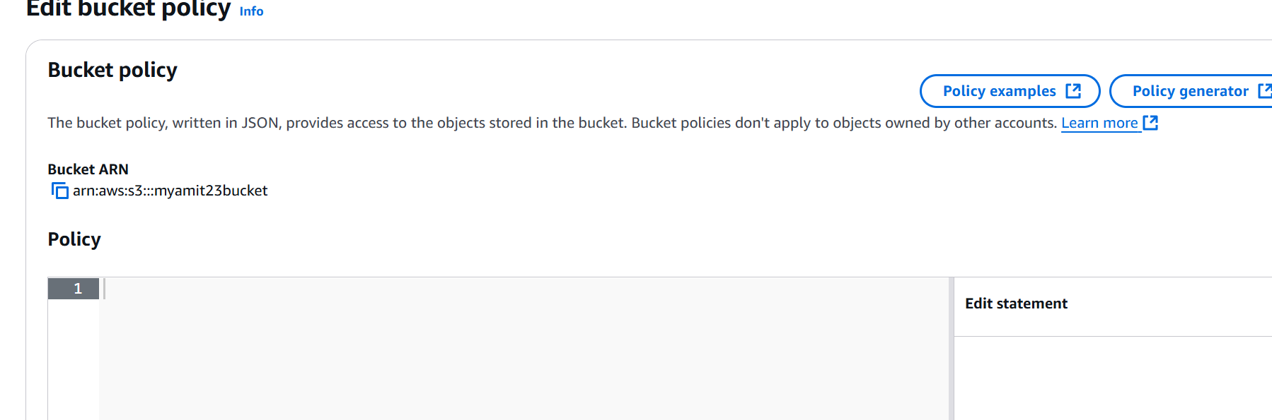

Click on Add statement, and generate policy

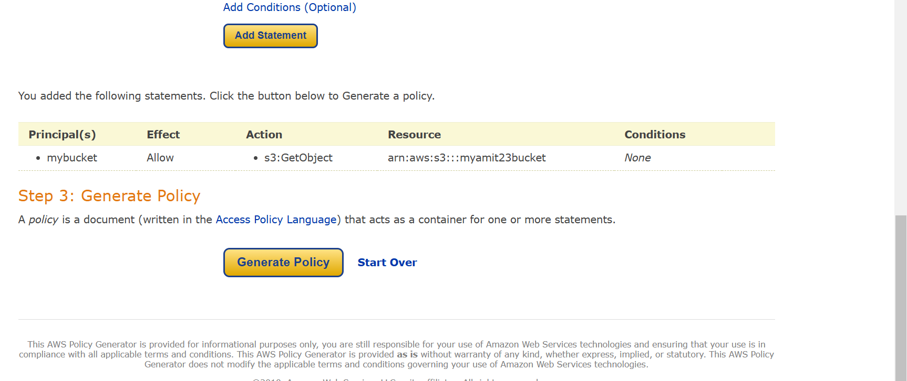

Copy the json format, from the site

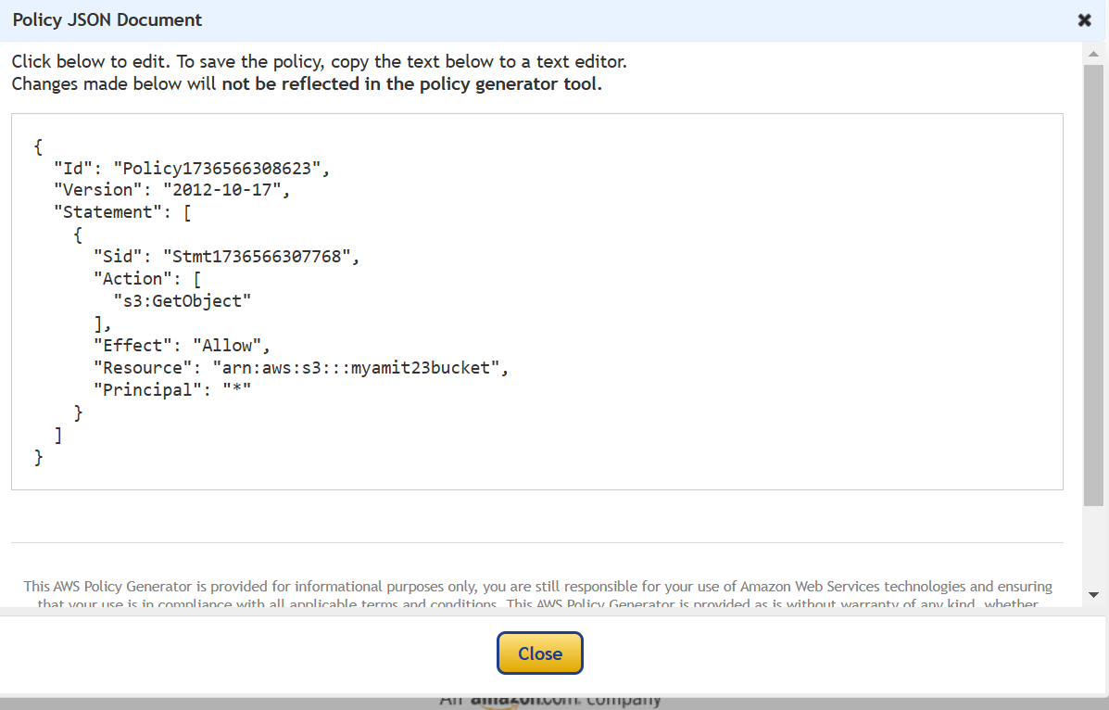

Go to bucket add policy option copy this json , If try to change it will fail

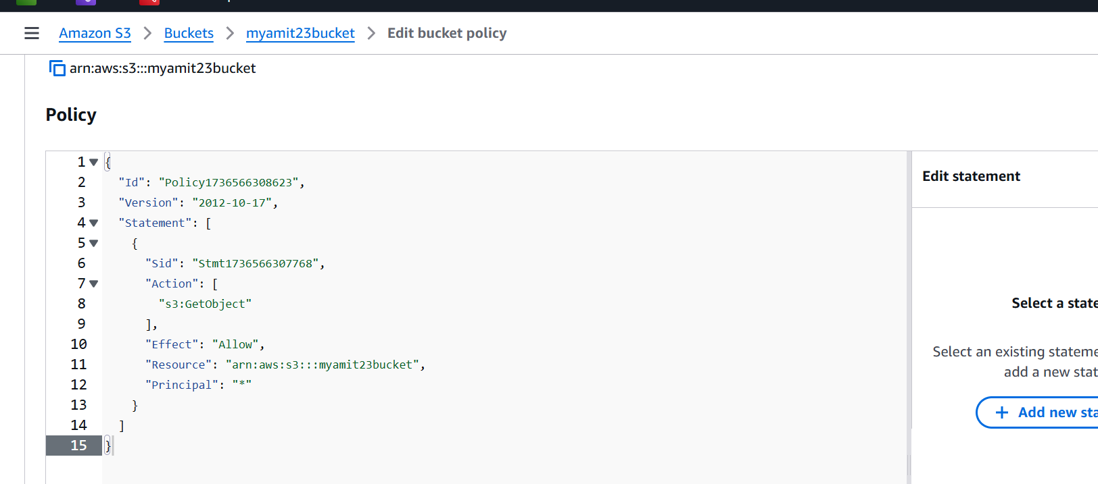

Go to Resource, make this change

{

"Version": "2012-10-17",

"Id": "Policy1736566538815",

"Statement": [

{

"Sid": "Stmt1736566307768",

"Effect": "Allow",

"Principal": "\*",

"Action": "s3:GetObject",

"Resource": "arn:aws:s3:::myamit23bucket/\*"

}

]

}

Now save the changes. Now try to access the bucket endpoint, it must work